**Position Analysis of Four Bar Mechanism (Grashof) - expT PROCEDURE**

**Objective:**

To completely determine the position of four bar linkage given and thereby find out θ and γ

4

(transmission angle).

**PROCEDURE**:

1. Read the values of link lengths under variables.

2. Read the value of θ under variables

2

3. Calculate the value of θ and θ

3 4.

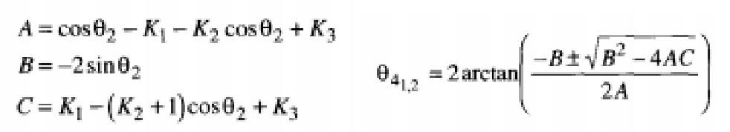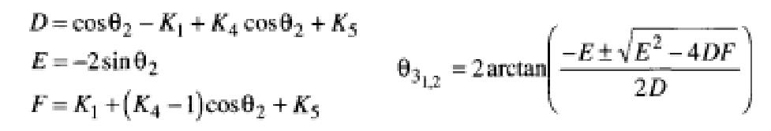

4. Calculate Transmission angle.

γ= θ- θ

4 3